HW4_Simulation Section (EE576)

Design and Simulation Problem

Instructor: Dr. Subhanshu Gupta

By: Mohammad Chahardori

ID:11632753

October 2018

Simulation Problem:
Convert the design in HW3 to a fully-differential amplifier (only change is the load capacitor).
Considering load resistor RD=500Ω, the capacitor C of 20pF, and Vdd=1.3V, you need to design a 2- stage fully-differential cascaded common-source amplifier with a source follower driving 20pF.
You are to use an 130nm CMOS process. The design goals for this circuit are as follows:
- Low frequency differential ac voltage gain > 12dB
- Low-frequency common-mode Rejection Ratio (CMRR) >80dB
- Maximum output swing > 0.6Vpk-pk-diff (peak-to-peak-differential)
- Unity gain bandwidth > 500MHz

Answer to the Simulation Problem:
In fig.1 the basic schematic of the circuit has been shown.

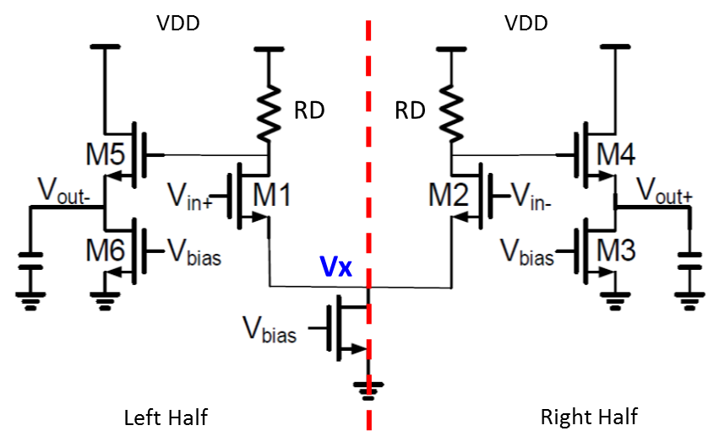
Fig.1. Schematic of the circuit

According to the required specification of the amplifier, the minimum low frequency differential gain of the amplifier is 12 dB which is about 4. To satisfy this gain after final circuit design, we consider 20% margin for this gain and assume the overall gain is 5. On the other hand, according to the differential half circuit structure (Right half of the circuit in fig.1) and considering the node Vx (M1 and M2 sources) is virtual ground in differential mode because it is placed on symmetry line, the amplifier differential gain in low frequency is:
(1)

The other low frequency specification of the circuit is the required CMRR > 80dB. According to the CMRR definition we have:
(2)
Also we have:
(3)
Now we need to calculate the common mode gin of the amplifier. Because of the symmetry of the circuit the two outputs of the circuit that is, and are identical in common-mode, so the differential output in common mode condition would be equal to 0. Here, we want to calculate the single ended common mode gain as . Now, considering half circuit in common-mode condition we have (for the Right half of the circuit):
(4)
Where M7 is the transistor of the tail current source which is connected to Vbias in fig.1.
Solving (3) and (4) together, we can achieve the value of .
(5)
The value of is really high. Since, it seems that we would not have very thigh swing issue in the first stage we can use cascade transistor in the tail current source instead of M7 to achieve this amount of output resistor. However, since we cannot change the circuit schematic we have to achieve using larger transistor length for M7. In fact for the value of based on the transistor small signal parameter definition we have:
(6)
So after calculation of we can calculate the required channel length of M7 to reach the required based on equation (6).
The other small signal parameters that we have to satisfy is the unity gain band width ( ) of the amplifier in deferential mode. According to the right half circuit of fig.1 in differential mode, the amplifier circuit shows two poles at node A (Drain of) and output node (). The values of these two poles are as bellow:
(7)

To determine the dominant pole, we have to consider the resistance and the capacitance which make these two poles. Although the resistance of node A is higher than output node, the output capacitance is much larger than the capacitance seen from node A. So considering the output capacitance of 20Pf, it seems that it is much easier to assume output pole as the dominant pole.
Now, to have the required , we have to pick up the size of M2 and M4 such that the summation of doesn’t exceed the borderline values of capacitor at node A. In fact to make sure that our assumption about dominant pole is correct we need to put the pole of node A in higher frequency than . In this case, we have:
(8)

According to the values of parasitic capacitors in 0.13um CMOS technology for usual sizing of M2 and M4 the parasitic capacitors would be less than 1.5PF which satisfy the above equation. But, it is necessary to check the parasitic capacitors after determination of M2 and M4 sizing.
Now it is easy to find the value of due to required . To find the value we can use the relation between Gain, dominant pole and . That is,
(9)

We have considered to make sure that is achievable after simulation of the circuit.
The third specification of the amplifier which should be satisfied by the designers is the swing at the amplifier output. According to the problem the amplifier should have 0.6V peak to peak voltage swing at the output in differential mode. So, for single ended swing in each side of the amplifier, we have:
That means each output voltages should be able to vary around its bias voltage without forcing any of the 3 existing transistors in the half circuit to enter the linear or cut-off regions. So it is important to set properly the output DC bias voltage. To find the proper DC bias voltage, first we should know the output voltage range that keeps all transistors in saturation region. This range can be calculated by determination of saturation region for each transistor as bellow:
(10)
The maximum voltage level is limited by M4 and the output bias voltage of the first stage of the amplifier that is the drain of M2. In fact, increase in output voltage can push the M4 transistor to linear or even cut-off region. Since the instant current of M4 is produced by the M7 bias current as the tail current source when M2 is on, it prevents M4 goes easily to the cut-off region and as a result, cut-off region for M4 is not critical here. From the circuit, it is seen that the limitation exposed by M4 when M2 entering to cut-off region and output voltage of the first stage goes up to VDD is much severe that linear region of M4 and it occurs sooner than the time M4 goes to linear region. Considering the cut-off condition of M2, we have:
(11)
It is worth to consider that the value of is larger than because of the big voltage difference between source to bulk voltage of M4 when M4 enters cut-off region and should be calculated from the formula.
Based on above calculation in which the minimum and maximum possible voltage at the amplifier output has been derived, we expect that the maximum possible swing at the output of the amplifier is:
(12)
As a result, to have the maximum symmetrical voltage swing at the output, the best output DC voltage should be close to:
(13)

Now, using equation (1) to (13) and considering the parameters of the transistors which have been extracted from simulation of an NMOS transistor in 0.13um CMOS technology and are shown in Table.1 we would be able to determine the sizing of transistors and bias voltages of the circuit to satisfy all the requirements of the circuit.

Table.1. Transistor Parameters
Parameter | Value
 | 350
 | 0.38 V
 | 0.5
 | 0.45

To start calculation of the transistor W and L based on the achieved values for gm we can consider a reasonable value for overdrive voltage of output transistors. We start with 0.1V to 0.2V voltage overdrive because it is far from the subthreshold region and also it is not too large so it would not limit the swing of the amplifier.
Considering for M4 andfor M3 based on equation(13) for the optimum value of output DC voltage to have maximum symmetrical swing at the output, we have:
(14)
In equation (14) we have considered the value of instead of since it has changed because of body effect. The value of is achieved by solving equation(13) and the value of Vth from equation (15) together and also by doing a simple simulation to achieve it.
(15)
It is worth mentioning that, by adjusting the output achievable swing would be:
This value is larger than the required swing at the output of amplifier. So we can reduce the from 0.35V to 0.25V that is 100mV which would relax the determination of the bias current of the first stage. In fact, by selecting we can increase bias current of the first stage, consequently we would have higher gm and it would be much easier to reach the required gain of the first stage. Now according to the value of we can calculate the current of as follow:
(11)

In this case, the DC voltage of the first stage output would be:
(12)
Now based on the value of which is obtained from equation (1) we have:
(13)
For transistor M4, since we considered and based on the calculated from equation (9) we have:

For the overdrive voltage of the M3 transistor we can consider 0.1V, for more swing capability In this case, since the bias currents of the M3 and M4 are identical, for the we have:
(14)

It should be noted that for M3 it is better to pick larger length than the minimum L. That is because, the gm of M3 does not have any effect on the amplifier performance and only the ro of M3 is seen at the output node. So, by choosing larger L we can completely ignore the value of ro3 compare to gm of M4 at the output node. On the other hand, if we consider L3 too large it may change the output capacitance which is not desirable. Here we consider the value of L3 about Lmin for simplicity. As a result, we have:
(15)

According to the symmetry of the circuit the sizing of the symmetric transistor should be equal. That is, the size M1 and M2, M4 and M5 and M3 and M6 are identical and they have similar sizing for W and L.
Now it is time to calculate the W and L of M7. Due to differential structure of the circuit in fig.1 the bias current of M7 is equal to the summation of . Considering 0.2V for we have:

We should remember that the value of would be several time larger than so the overall size of M7 would be really large. Since we don’t have tight limitation on the swing in the first stage, we can consider higher value for to reduce . In fact, the DC value of the drain voltage of M2 (the output of the first stage) is 0.85V based on (12). So, even with single ended swing at this point we would have 0.65V headroom to keep M2 and M7 in saturation region. Since we considered so we can allocate up to 0.45V to . For example we can set at 0.35V. In that case we have:

As it is seen in the above equation(), this change in decreases the about 4 times. Now we should calculate the based on the and . As we mentioned before for we have:

The last step is to derive the appropriate values for the bias voltages of the circuit based on bias current, overdrive voltage of transistors and the transistors parameters.
The required input DC voltage at the gate of M1 to set the current of M1 at the required is:
(16)
The other DC voltage which we should have calculate is gate bias voltage of M3. With the considering for M3 we have:
(17)

Now based on calculated values for transistors W, L and bias voltages of the circuit we can design and simulate the circuit in the Cadence software.

Simulation:
Based on the values achieved through calculation the circuit has been designed. Some modification in size and bias voltage has been done to achieve the required gm, gain and other specs of the circuit. In table 2 the final values for transistor sizing and bias voltage are shown.
Table.2. Real sizing after simulation
Parameter | Value
Current Consumption | 830
Vin (DC) | 450 mV
Vb | 550mV
 | 400
 | 12
 | 12

The circuit with DC operating points has been shown in fig.2. The simulation results for ac response and transient response are shown in fig.3 and fig.4. As it can be seen, all the requirements of the circuit are in acceptable range.

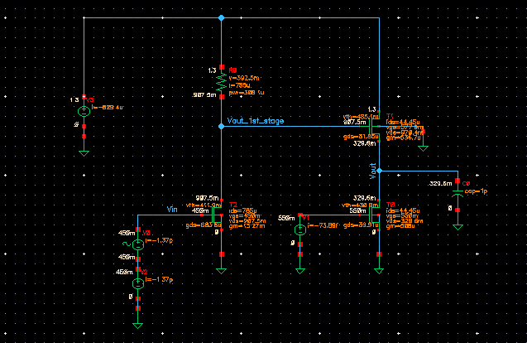
Fig.2. Schematic of the designed circuit with operating points

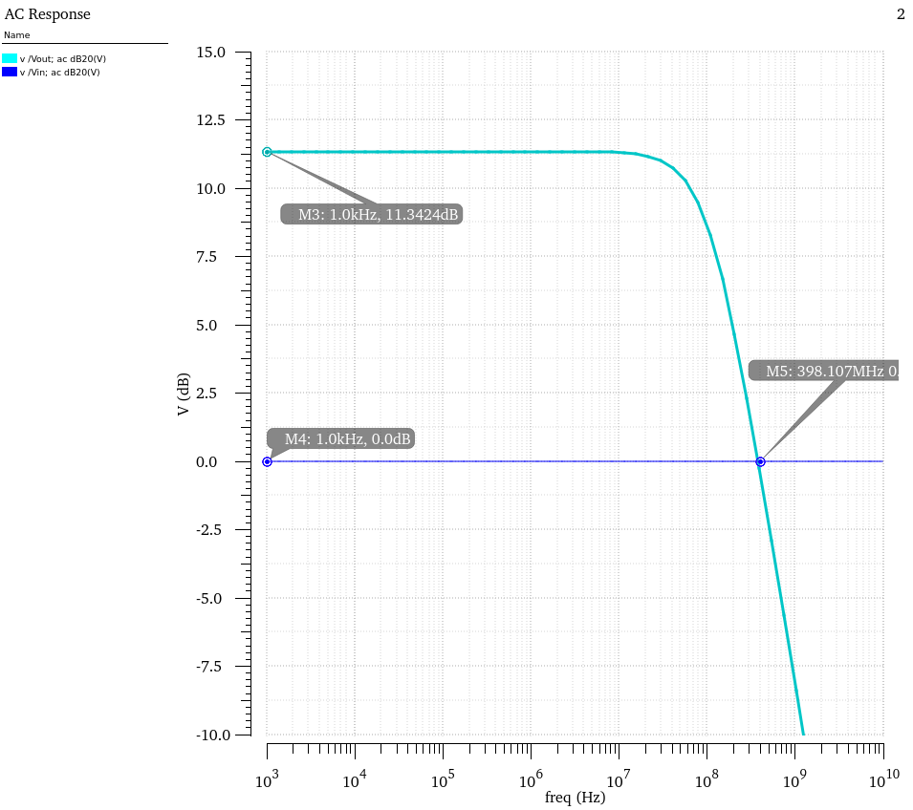
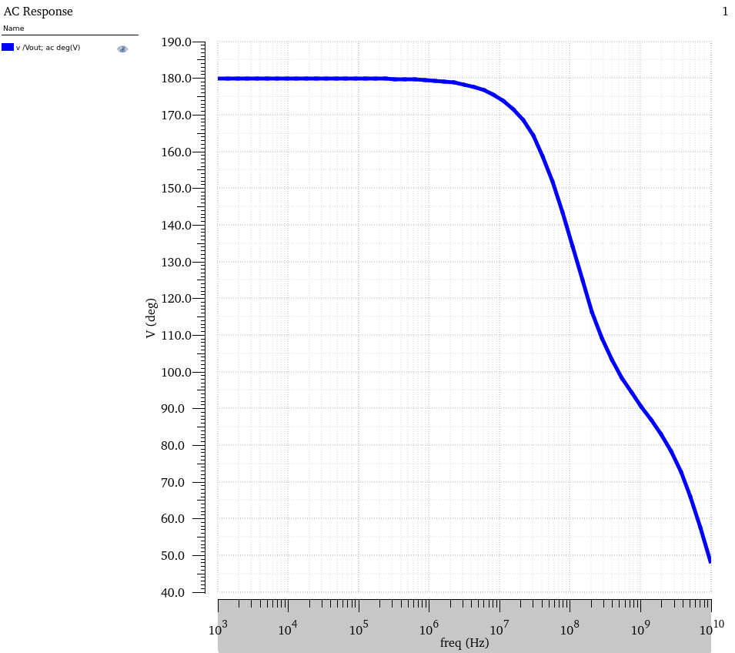
Fig.3. AC Response

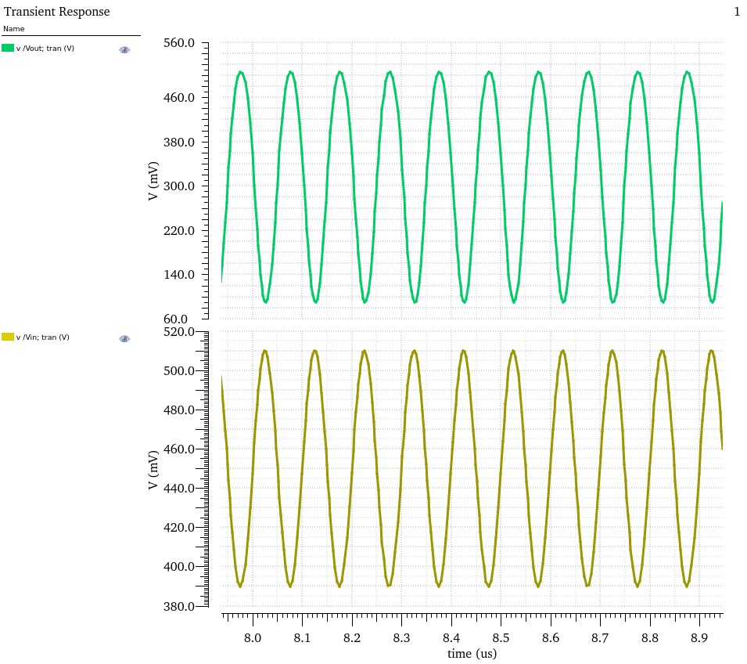
Fig.4. Transient Response

